Nama : Elsadanika Maura Sitorus
NIM : 211344013 – 2NK
Praktikum 3 APKOM
- Hasil Praktikum
- Poin e,
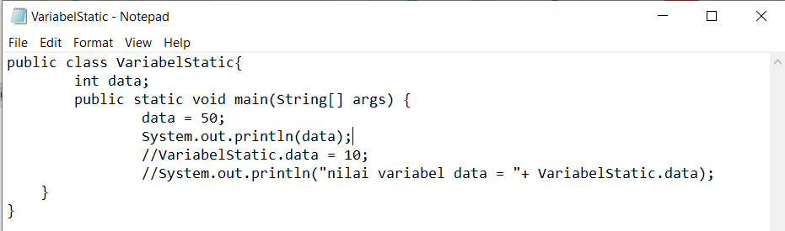
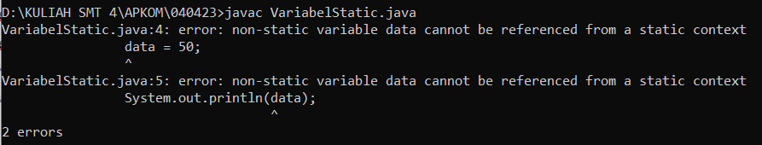
- Poin g
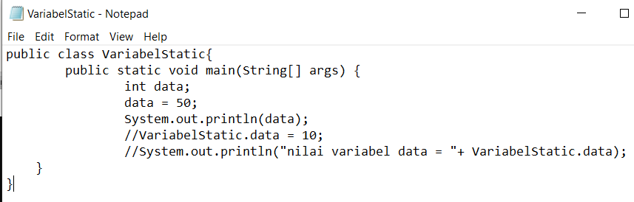
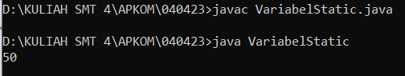
- Poin i
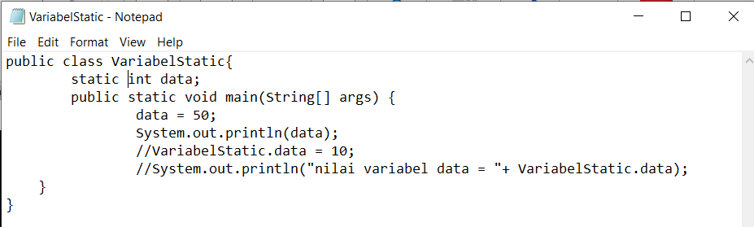
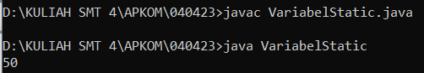
- Poin k
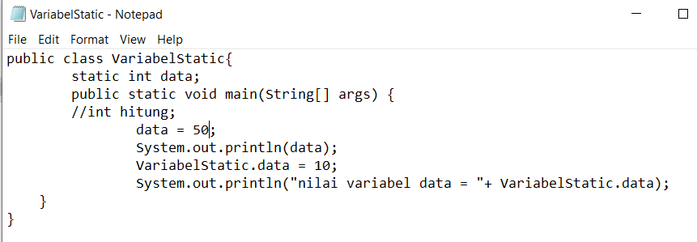
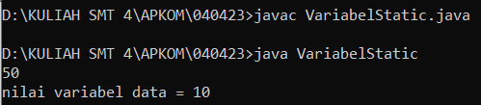

- Hasil Praktikum
- Poin d
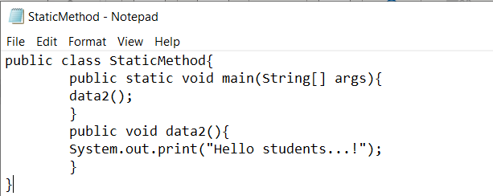
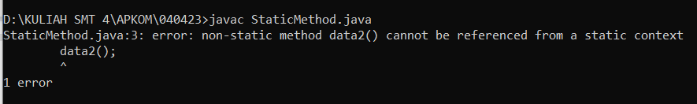
- Poin e
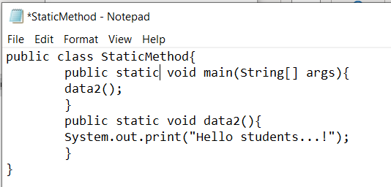
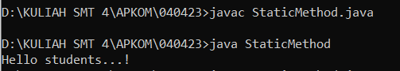
- Hasil Praktikum
- Poin f
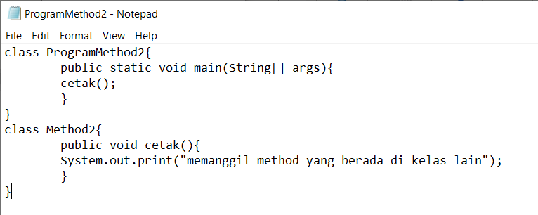
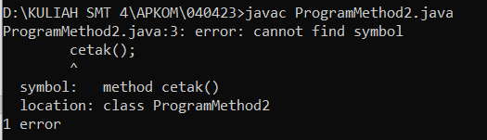

- Poin h
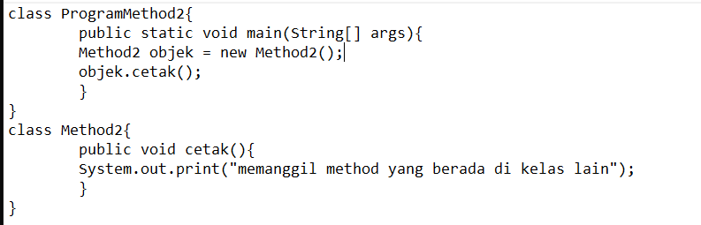
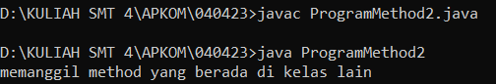
- Hasil Praktikum
- Poin f
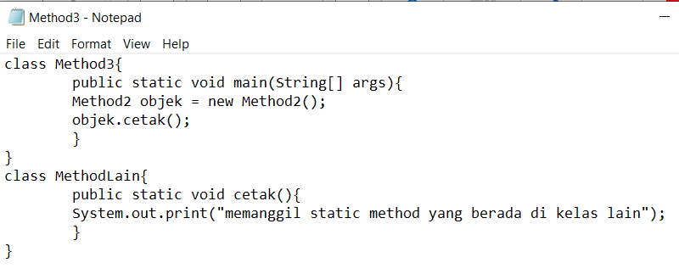
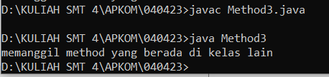
- Poin h
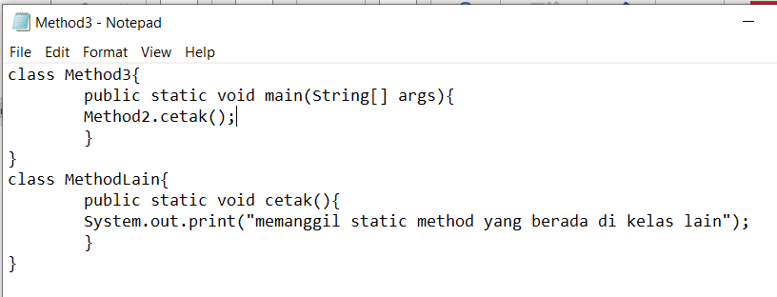
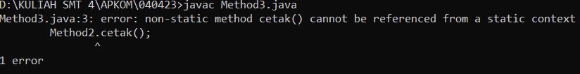
- Hasil Praktikum
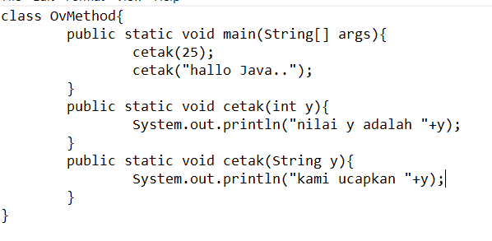
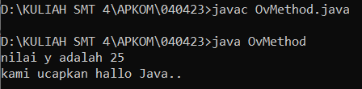
- Hasil Praktikum
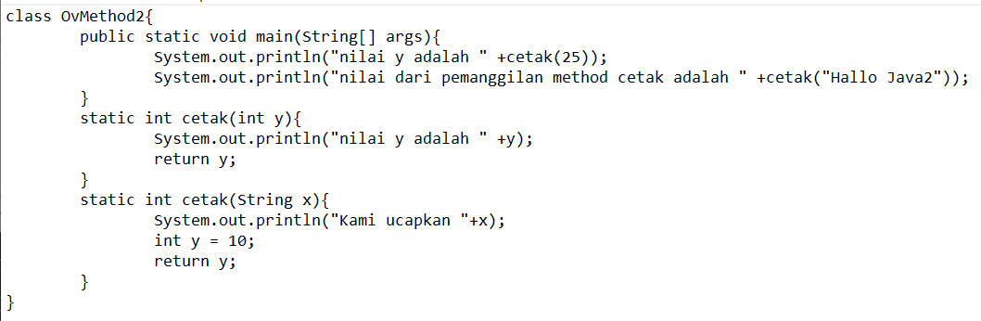
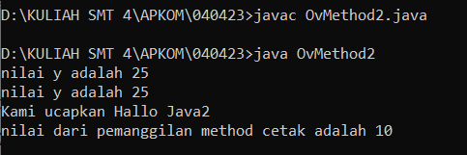
- Hasil Praktikum
